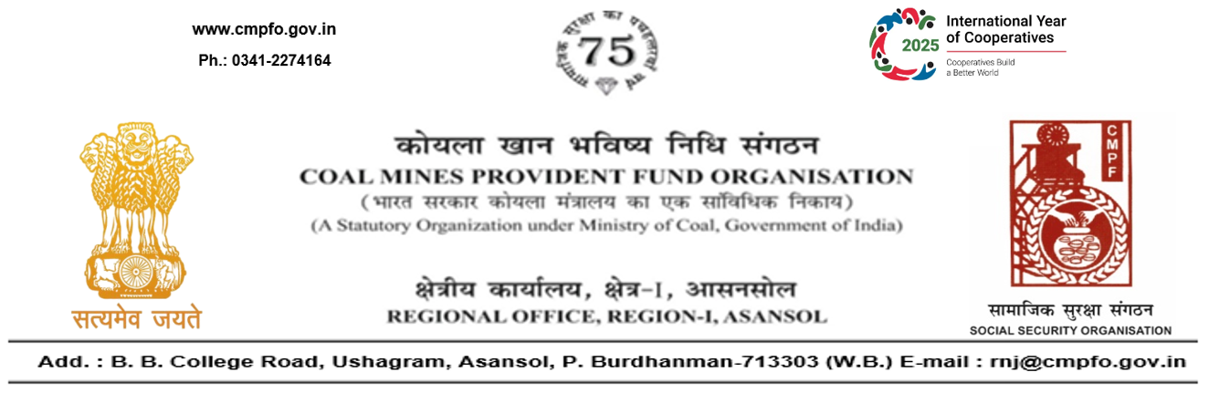
SL. No. :117
CPF/118/Misc/L.C.Out./RNJ-41/R-I/ASN/ Date:06-01-2026

To
The Regional Commissioner
Coal Mines Provident Fund Organisation
PO-Jaripatka, Dist-Nagpur -440014
Maharashtra

Sub:- Inter Regional Transfer of Ledger Card, DA, PS -3 & 4.

Ref:-CPF/NAG/Misc/L.C. Req./NAG/78/1462 dated 26/12/2025
Sir,
In view of the revised Procedures prescribed in Procedure Office Order No-35 Dated-12.02.1975 of CMPF Commissioner,Dhanbad, I am to state that the Ledger Cards of the following members is hereby forwarded to your Regional Office. Further, it is informed that the Form A & P.S.-3 & P.S.-4 forms are not available in this region.
It has been ensured that the posting in the Ledger Cards have been made/updated for the periods the member was working in this Region.

SL. No | Name of the Member | CMPF A/C No | Name of the colliery where the member had earlier worked in | Name of the colliery where the member is currently working in
1 | Shri KOVVURI Veerendra Reddy | RNJ/41/133 | Sonepur Bazari Area (RNJ/41) | NGP/78

Please acknowledge the receipt of the above at the earliest.

Yours faithfully,

(Ajay Kumar Singh)
Encl- Original L.C. (OneNos) Regional Commissioner - I

